Challenge-3

First Challenge
- Launch one EC2 instance using Amazon Linux 2.
- Install Docker.
- Install Jenkins.
- Install Apache.
- Install Nginx.
- Install Apache Tomcat.
Everything needs to be setup and running on the same EC2.
You can change the port numbers as required.

Installing Docker on Amazon Linux Machine
Log on to AWS console and make ssh connection to the aws linux machine.
Go to root user and update the os using ‘sudo yum update -y’
Install docker using the command ‘yum install docker -y’

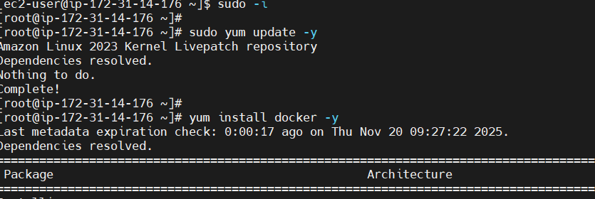
Verify the docker using the command ‘docker –version’

Start docker using the command ‘ systemctl start docker’ and check the status using the command ‘ systemctl status docker’

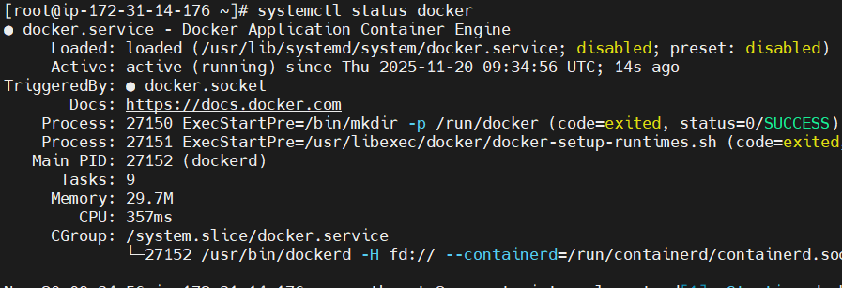

Installing Jenkins in AWS Linux
Inorder to install the Jenkins we need to install java, for installing Jenkins latest version we need the JDK 17 as the required version of java.
Install JDK 17 using the command ‘ sudo yum install java-17-amazon-corretto -y

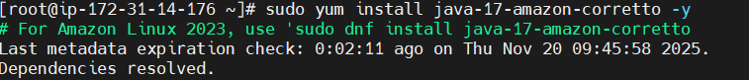

After installing the java check the java version using the command ‘java -version’
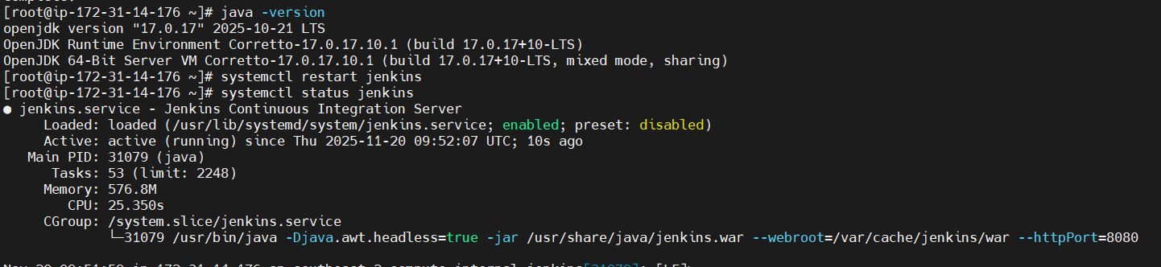
Install Jenkins using the command ‘ sudo yum install Jenkins -y’
After successful installation of Jenkins, start the Jenkins using the command ‘systemctl start jenkins’
And check the status of the Jenkins using ‘ systemctl status jenkins’
Jenkins runs on the port 8080 as the default port, go to the address ‘ public_ip_address:8080’
Retrieve the password using the cat command and enter the password and install the required plugins to open the welcome page as follows.
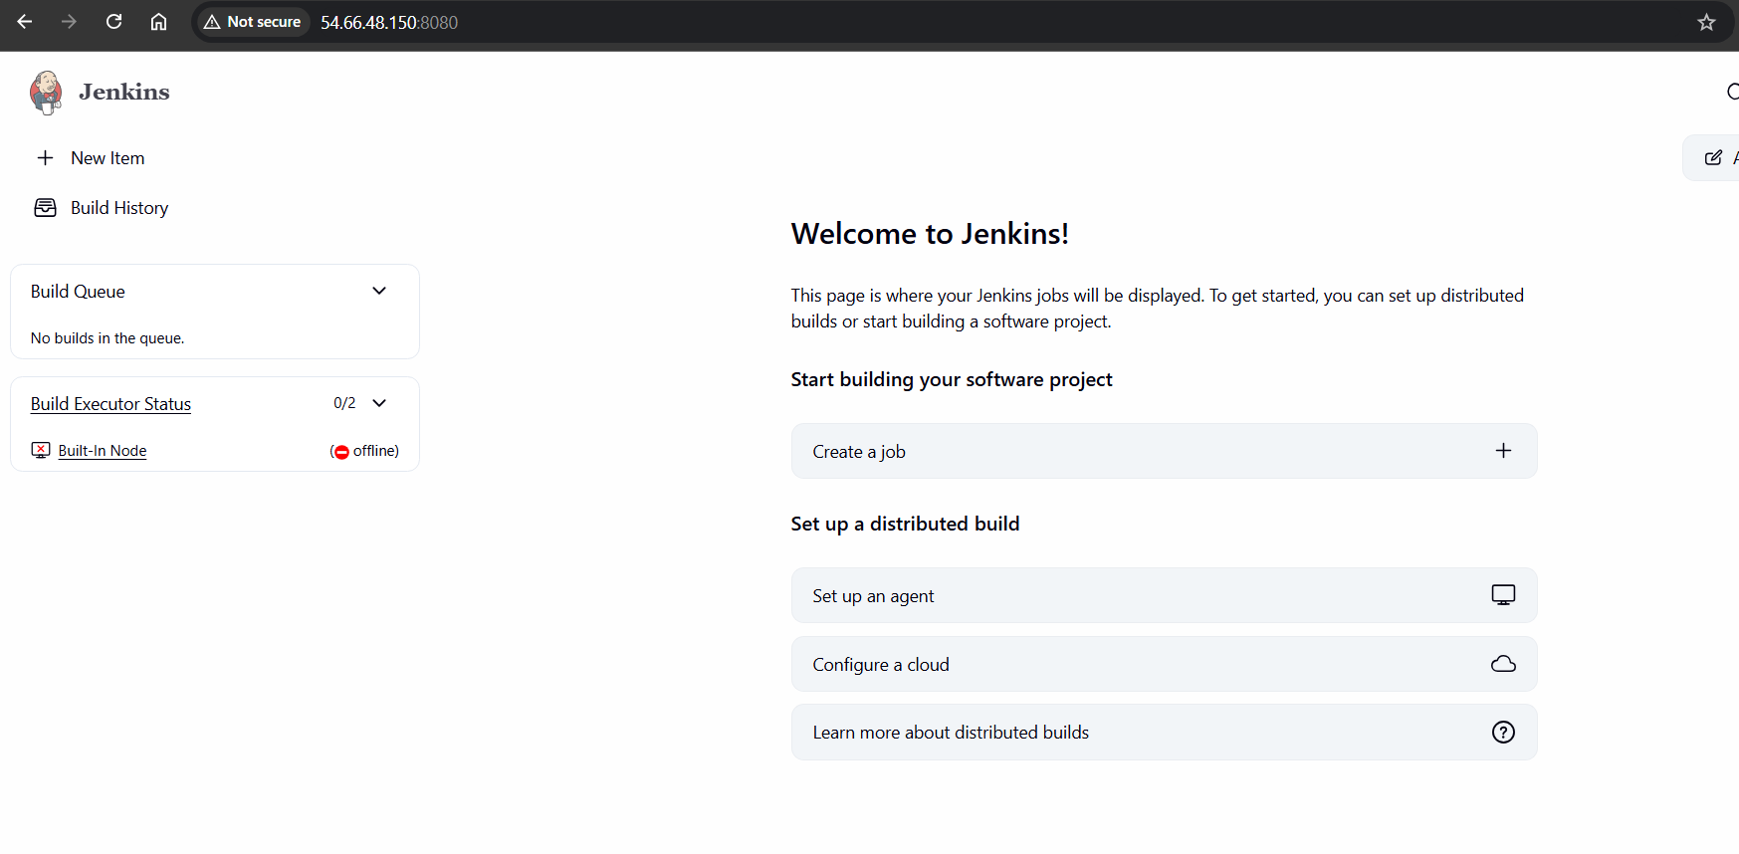

Installation of Apache httpd server
Install httpd server on the machine using the command ‘ yum install httpd -y’

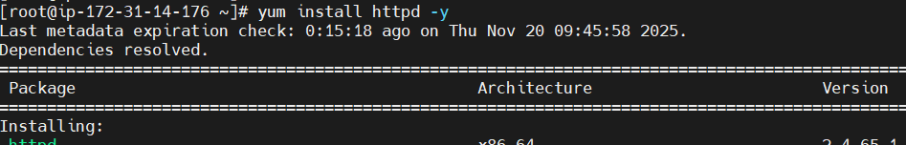
After installing the server, start the server by using the command ‘ systemctl start httpd’
Check the status of the server, using the command ‘ systemctl status httpd’
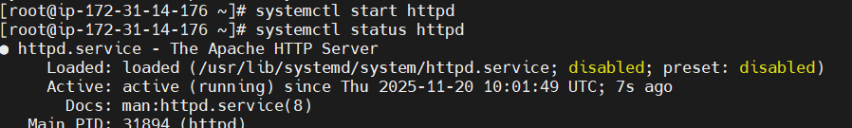

Httpd runs on port 80 as default port, Enter the server home page using the URL “Public_ip_address:80”
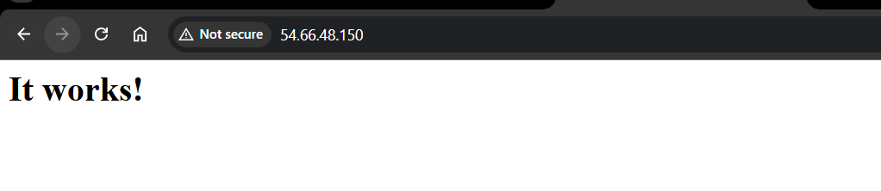

Installation of nginx server on Amazon linux machine
Install nginx server on the amazon linux using the command ‘yum install nginx -y’

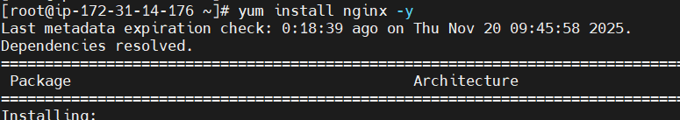

After installing the server, before starting the server, go to the configuration file located in the ‘/etc/nginx/nginx.conf’ file, since the default port of the nginx is also same as the httpd server installed earlier in the same server we need to change the port number of the nginx server.

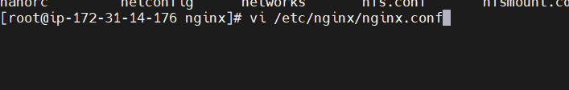

In the vim editor type the ‘:set number’ to easily locate the listening port, go to line 38 and 39, change the default port 80 to 81
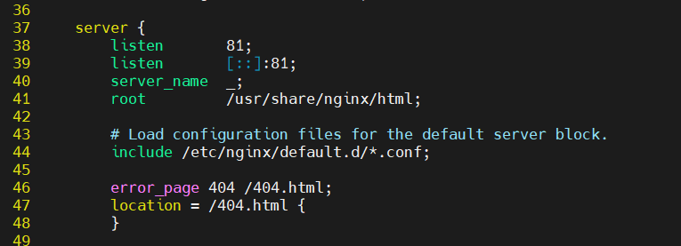

Now after making the changes restart the server using ‘systemctl restart nginx’ and check the status using ‘ systemctl status nginx’
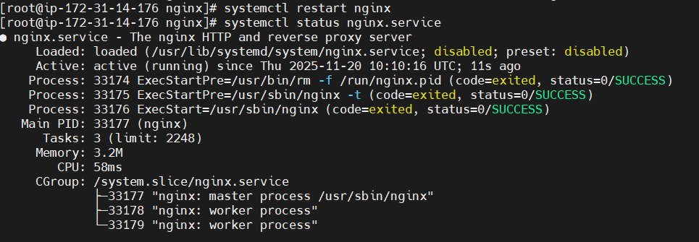
Go the nginx home page using the URL “Public_ip_address:81”
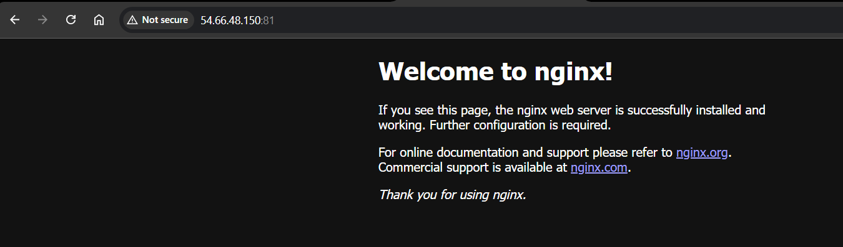

Installation of Apache Tomcat server on Amazon Linux Machine
Go to the /opt folder to download the tomcat server installation files
To download the tomcat type ‘sudo wget http://downloads.apache.org/tomcat/tomcat-9/v9.0.111/bin/apache-tomcat-9.0.111.tar.gz

After the download is complete extract using ‘ sudo tar xvf apache-tomcat-9.0.111.tar.gz’

Move the extracted files to the new folder tomcat using the command ‘sudo mv apache-tomcat-9.0.111 tomcat

Move the folder tomcat
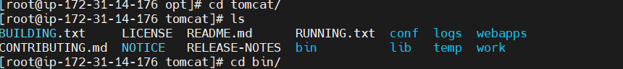
Navigate to conf folder and open the server.xml file to change the default tomcat server port no 8080 to 8081 since the running machine contains the Jenkins server running on the 8080 port.
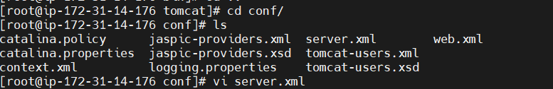

Navigate to line no 71 and change the connector port to 8081

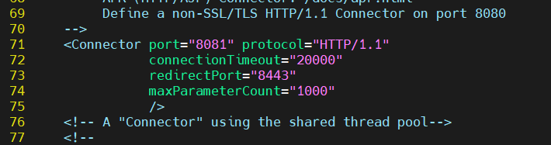

Now go to bin folder and start the script ‘ startup.sh’

Go to the browser and type the URL as follows ‘ Public_ip_address:8081” and we can see the tomcat home page as follows.

